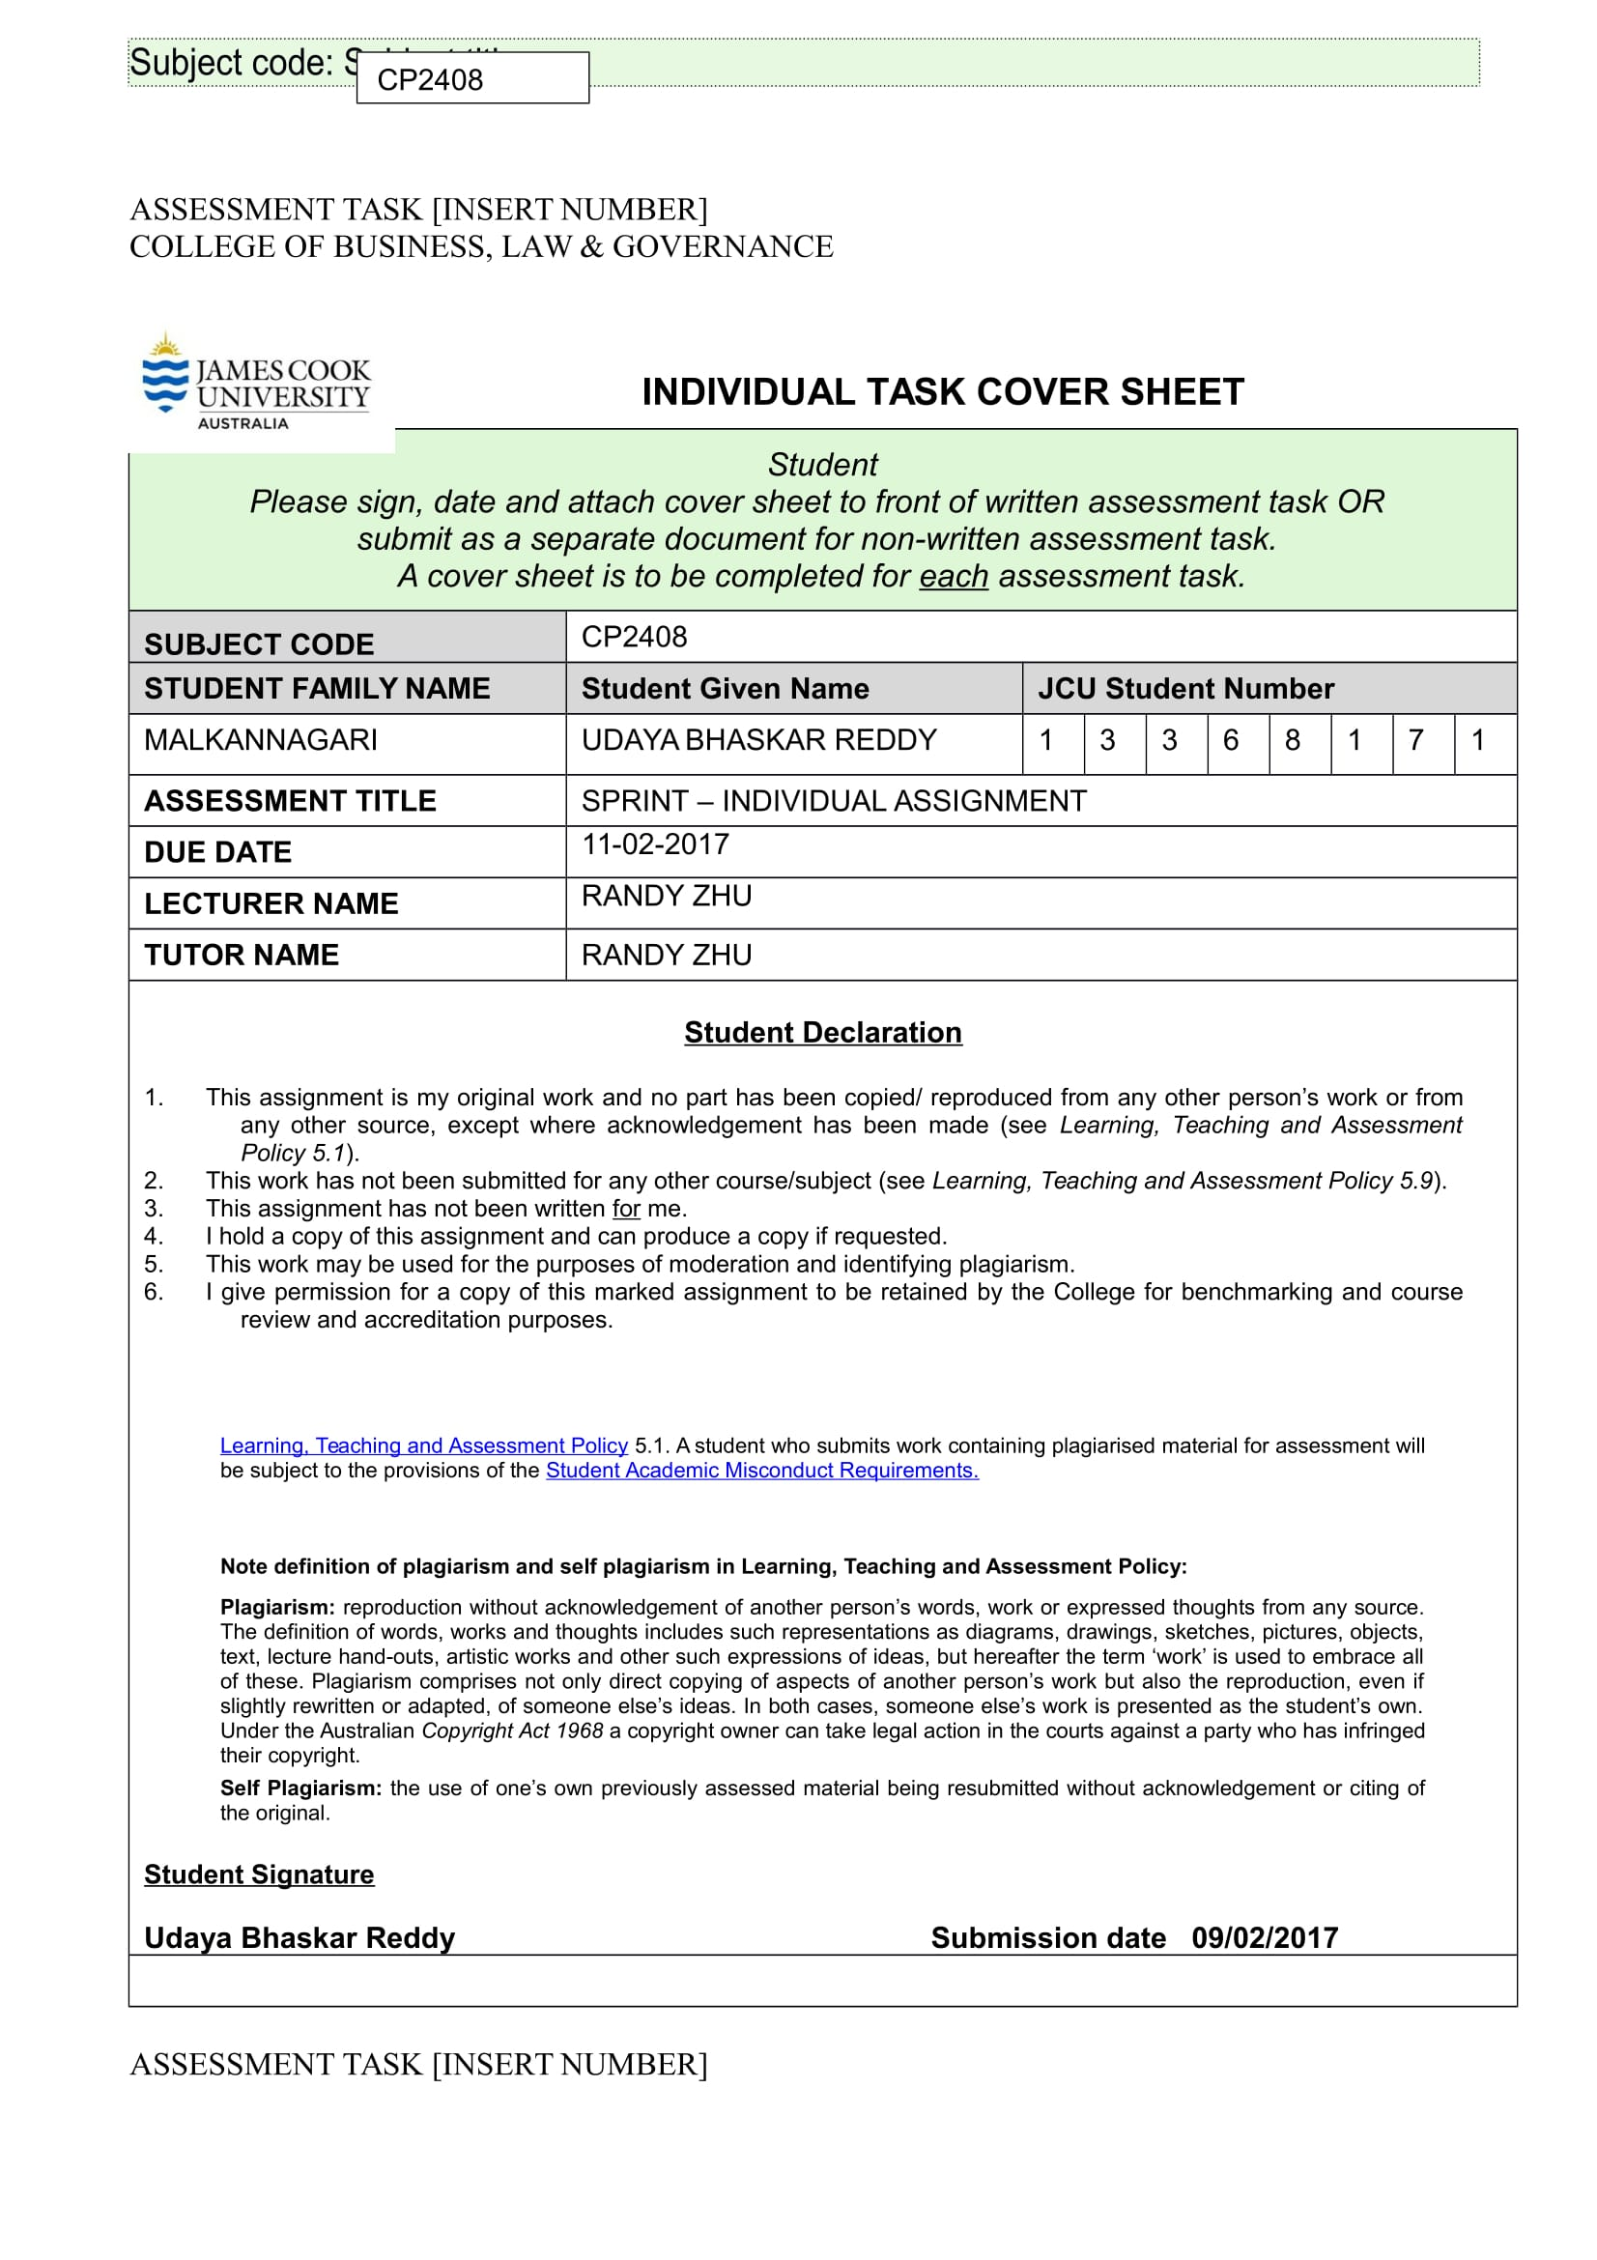

**Sprint Reflective report:**

**A reflection on the design thinking process:**

In this report, I will be describing my own role in helping the team achieve its goal during all stages of the SPRINT. My experiences of the SPRINT turned out different when I compared it with the experience of our previous assignment. Even though the same lean UX methods and ideas were implemented during both the projects, the time constraints of the SPRINT made it a much more challenging and engaging task to me as a participant.

The advantages of the lean UX process was much more evident during the SPRINT. As we were already on a timeline to finish the tasks, I realized how effective lean UX can be in such a scenario. However, I believe, that lean UX methods have a natural flow to them in incorporating itself within the framework of the whole design. It was not an on/switch that was immediately giving the desired results, but rather a gradual shift in my mindset that took me through the journey of product design in a step-by-step manner.

The challenge our team chose was to use disruptive technologies as a startup company to change how delivery services function today. The challenge was to make it a cost-effective enterprise. This challenge immediately struck a core with the entire group. When I started researching online, I came across several opinions in support of the lean UX approach that can be used in this particular scenario.

There were several questions I was trying to answer before formulating my opinion on this topic. The central point for my research was to analyze the reason to why most startups fail. The primary reason is because they fail to create offerings that people want. The user perspective was the key in this approach. And this was the core of the lean UX methodology. I felt that as a startup company there will be several initial risks involved. These risks may include the market risk and the technical risk. As I have applied the lean UX approach in my previous works, I felt that it can be the most effective method to reduce market risk when there are time constraints and initial hurdles. The SPRINT experience was, in a nutshell, an eye opener for me to look at the effectiveness of such methods.

***Validating the Assumptions:***

The relevance of lean UX came to the fore during the assumptions stage. Validating the assumptions with user formed the critical part of the whole exercise. During the SPRINT, the team had a limited scope to implement this idea. Going back to the user to validate our assumptions and design choices is the core idea of the lean UX method we were using at this stage of design. But we needed students who can put themselves in the shoes of the retailer and give us appropriate feedback. I suggested the team choose students who took the same challenge as us, the supply chain industry. I felt that as they were dealing with the same challenge, they will certainly have a basic understanding of the issues involved with the topic related and can help us give a consistent feedback on the design choices we made.

Declaring the assumptions and testing them during the hectic schedule of the SPRINT was challenging. But the immediate result of going back to the user was visible much more clearly during this phase. The users were giving valuable inputs on our assumptions and features. I believe, it essentially made the user a part of our development team. Most of our assumptions and design choices were in line with the thoughts of the user. This can also be attributed to the initial work that our team put in researching the pros and cons of every assumption we made. This made me realize the significance of a good start when working within the constraints of time as in a SPRINT. If the team were to lost track at this point, our project would have ended up as failure. This lean UX method of a good research(think) followed up by an interaction(check) with the users to validate our ideas is the core element that defines the success of our project.

After validating the assumptions from the users, I realized that,

* Every decision we made about the offerings in the product was a design decision.
* Every design decision was a hypothesis
* Declaring assumptions and testing them was the most critical time saving part of the whole SPRINT exercise that avoided waste of energy and resources.

***User testing:***

I would like to analyze this phase from a different perspective to explain its significance. While conducting user testing during the SPRINT, a question kept arising in my mind. What if we were not testing the users to validate our product? How do we know that we were on the right track? What if a user dislikes the design choices we made after we implement them in our final design? Considering we only had two days to accomplish our task, our design choices needed the approval of the user to move forward. In the end, I felt that no other method would have been efficient enough to validate our design choices except getting it directly approved by the user himself.

Assumptions were like generating many options to resolve the issues. User testing, I felt, was a stage that helped us decide quickly which ones to pursue. We used paper drawings for the first iteration. This was also a significant method of making corrections quickly. And, I felt, it was an essential requirement during the SPRINT session in comparison to the previous assignment where we had an ample amount of time to work with. The team went through rapid cycles of think/make/check during this phase. I suggested that the team put in all the features we would like to incorporate in the drawings and make the design basic and understandable to user. The initial design of the first prototype was only used as a tool to validate the features incorporated within the product rather than an example of a good design. The time constraints in the SPRINT made us take a collective decision on this approach. And, I believe, it yielded the right results. The team was able to make changes on the go and the features were added/deleted according to the user inputs.

The most important feedback during the user testing was about the cost effectiveness of the whole system in relation to the existing delivery services in the market. One of the users I tested was unaware of the costs involved in using the drone technology instead of traditional methods. This phase helped us research more on this insight. Our team already had an initial understanding of the economics involved in the building and usage of such technology, however, the user inputs prompted us to investigate further into the relevance of this idea in the context of a city like Singapore. I felt that user testing was both a learning and training experience that refines the initial ideas we have come up with into a more operational form.

Another big advantage of this lean UX method is it unites different members of the team under a common goal. In our case, each member was essentially assigned different tasks. Surya was involved in story boarding, Spurgeon was involved in researching, me and other group members were involved in designing prototypes and documentation. However, each one of us were eager to study the user testing results as we had the same goal of validating the hypothesis.

The main disadvantage, I see of this method in the context of SPRINT, is the basic framework of structure that it works in, the trial and error methodology. Initially I was unsure if the user inputs can be incorporated within the stipulated time frame of two days. As it was a trial and error method, we will never know how many more iterations it will take to get the approval and satisfaction of the user. I feel, by using this method, we can guarantee some kind of learnings by the end of a certain time-boxed period, but we can’t truly say that the product will be ready to launch on a certain date because we don’t know if it will work or not. Especially, in the context of the SPRINT, this issue was more evident.

***Value of lean UX methods in the Design thinking process:***

In order to explain the value of lean UX methods in the context of sprint, I would like to give a brief summary of the actual processes involved during the two days of the SPRINT exercise.

* Defined the long term goal of the project
* Made Assumptions
* Created Hypothesis based on the assumptions
* Created the first MVP based on the assumptions we made
* Interviewed users to validate our assumptions
* Conducted user testing for refining our product based on their insights.
* Worked on the second iteration using the user feedback as a central point
* Conducted another user testing, going back to the user
* Made the third prototype and user tested it for their approval of the final design

Every lean UX method involved in the process revolves around the user. This kind of methodology is extremely beneficial in the case of startup companies like us. It saved us from going along the wrong path by being in constant touch with the user needs. This process allowed us to avoid a lot of wastage during the refining process of the design. If the user was unsure of a feature, the team immediately looked into it and tried to clarify the issue within ourselves and went back to the user again. A project that could have taken atleast a week or two to finish was essentially completed during two days of the SPRINT. Furthermore, as Lean UX involves a lot of trial and error, knowing what to do when you fail becomes a huge part of making the right decisions. Our team needed to understand where we went wrong, have a process for tracking and measuring the feedback, and spend time discussing it with our team — then it is time to start making decisions and repeat the process until we get it right.

However, this process may not be effective in the context of bigger projects that involve higher costs. Such kind of projects may need more expertise and organizational structure and such lean UX methods may not be entirely successful in those scenarios.

***Interesting things:***

The most interesting thing about using the lean UX methods for the project is realizing its positive when used in the context of a session like SPRINT. In comparison to our previous assignment where we had no time constraints, the efficiency of the lean UX methods are much more visible during the SPRINT.

***Personal reflection on the Design process experience:***

This experience taught me the value of a human-centric approach in solving problems. The lean UX methods deal with the user as a central point of focus in solving a problem. It also helped me understand the value of a time-effective solutions. With the changing trends in the market, consumers demand a more time-friendly approach from the businesses and it is essential to cater to these demands in order to sustain in a competitive business world. Lean UX, I see, is a path in the right direction that helps in finding a solution to the consumer’s needs.

**A reflection of the prototype designs:**

**Thoughts on the various stages of design of the prototype:**

***First iteration – paper drawings:***

The first iteration of the prototype acted as a means of validating our features with the users. The team used paper drawings as a tool to communicate our product design with the user. This was crucial as changes can be made in quick time based on user insights. Had we chosen a digital prototype for the first iteration, it would have been difficult to complete the project in the two days of the SPRINT. The first prototype was designed by incorporating the features based on the assumptions the team came up with regard to the issues the retailers face in the delivery of goods. I played the role of a ‘Designer’ during this iteration. This gave me a closer understanding of the features of our product. The main challenge I faced with the design is to find out a way to incorporate the key features that catch the users attention. The call to action must be highlighted.

The one feature that helps us stand out in the competing market world is the implementation of the new drone technology for delivering goods. This technology is still in its budding stage of usability. Our team believed that it can act as a cost effective means to deliver goods in a short distance radius. By saving manpower and diverting the funds to drone maintenance, the costs can be significantly reduced. But it also depends on the weight of the product that is delivered. For this purpose, in the “Place the Order” section of the main page, I tried to highlight the “weight” factor with regard to the user choice. During the testing, the users were easily able to identify the relevance of this metrics I used in the page.

Another page design insight that I came up with is in relation to the “Track my package” that allows the retailers to constantly track the status of the package enroute to its destination. I used a map as an interface to highlight this feature. These are simple methods that I, along with my team, used to convey our design choices to the user.

However, our primary goal was to validate the relevance of the features more than the actual design. The prominence of features overshadowed the actual design of the website during this stage. This type of approach helped us save a lot of time in the context of the two-day SPRINT. Repeated user testing also helped avoid wastage of our energy on unfruitful tasks and set us on the right path of refining the product further according to the user needs.

***Initial sketch of the tracking page with the map:***

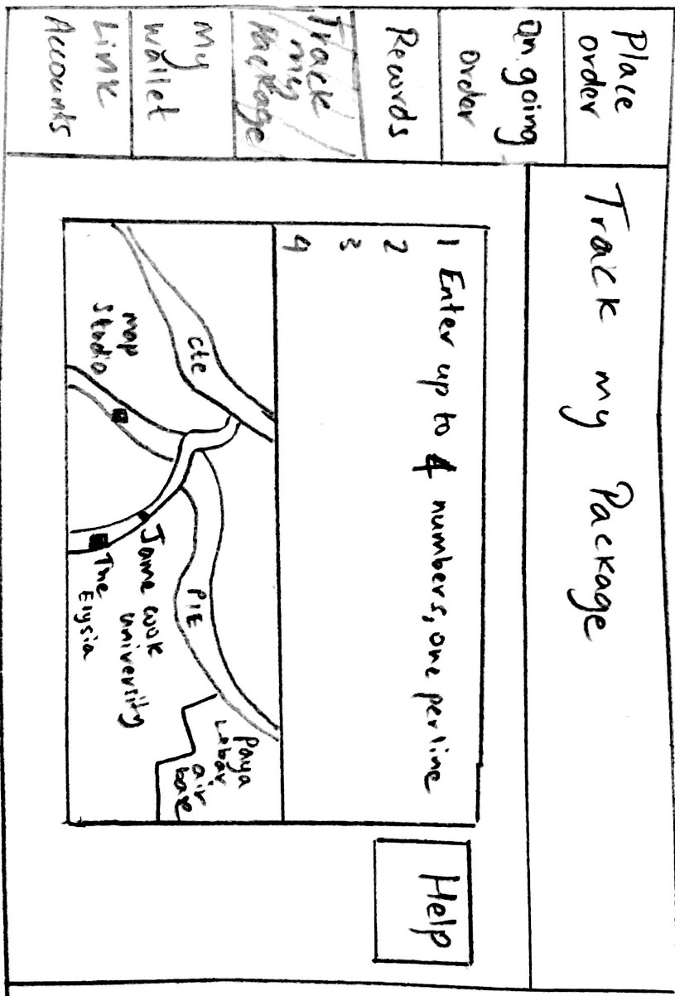

***Second iteration – Low fidelity Prototype:***

The second iteration was a digital prototype. The team decided on the transformation after validating all the core features we wished to incorporate in our design. I suggested we make a complete overhaul of the initial design that we came up with. But time constraints forced us to stick to a basic design layout for this iteration. However, we worked hard to make it visually as appealing as possible. I played the role of “Designer” during this iteration. But having had the additional responsibility of managing the group and its functions as a team leader, I had to engage the services of my other group member Vihangi during the later stages of the prototype design.

For the actual design, we wanted the navigation system to be user-friendly. This digital version gave us a chance to highlight the core elements with the help of images and colors. This was significant to catch the user’s attention. For example, while placing an order, the “choose a vehicle” type or the “drone” pickups was highlighted with the help of colorful images. This gave a natural user-friendliness for the final design. It was also evident during the user-testing. For the “track my package”, I included a search button for the user to input their “Track ID”. There were some minor additions like using some basic colors for highlighting key elements in some pages. These pages include, the Ecommerce link page, booking the orders based on the number of items and sizes etc., All these changes were possible with the of the digital version of the prototype.

The user testing made me understand the significance of this version of the prototype. The users were immediately drawn to the key elements we tried to highlight. The navigation was also easy and smooth. Overall, this version of the prototype had importance to both the features and the design in equal measure. This was like transition phase from one stage to the next.

***Using images of the drone and vehicles to communicate our idea:***

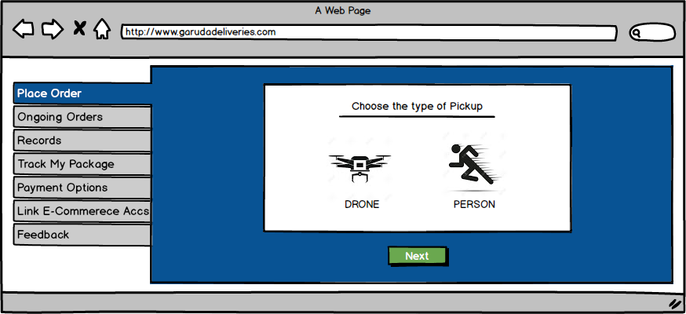

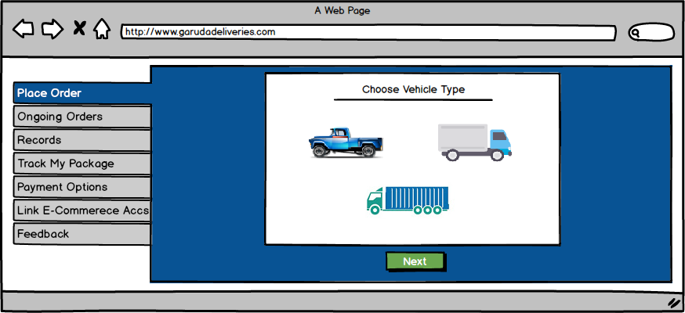

***Third Iteration – High fidelity prototype***

The third iteration of the prototype was the high fidelity version. This, I believe, is the next step in enhancing consumer usability. When we started out with the basic sketch layout for the first prototype, I couldn’t envision that the final prototype will turn up this good considering we have to finish this task in two days. I think the testing phase provided us with many valuable user insights to come up with the design for the final prototype.

The primary purpose of our website was to serve as a means to enable a retailer-friendly interface that allows for quick navigation and calls to action. The retailer must be able to place an order immediately to deliver their goods and also choose their mode of transport. They must also be able to track the status of the goods in real time, receive feedbacks from the customers, link their e-Commerce accounts to the website and make easy payments online. All these features along with others were effectively implemented in the final MVP. The users we tested were extremely satisfied with the scope of the final design choices they were offered. This time, the users were attracted to the navigation system we used to present our product. We used the marvel app software to link the various pages and created the flow of an actual working website.

After conducting the user testing for this iteration, I realized that the third iteration was more about the design and usability of the product and less about its actual features. Since the user was already aware of the features we incorporated they were more interested in the interactivity of the web page and the easy of usability of our services offered. For example, the users were instantly drawn to the “Ongoing Orders” page which did not happen in the previous iteration. This was a result of the changing color themes used within the context of the page. It gave the user a complete status of the product we delivered including the option to track, which is highlighted with a green flag. The users found the map features to be more interactive than the previous versions. Overall the design overhaul was well appreciated by the users considering the time we had to work on the project.

Overall, I believe this prototype will serve its purpose well by giving the retailers an option to make quick deliveries and payments. The services offered by our company were highlighted clearly on the web pages.

***Image of the Ongoing orders page:***

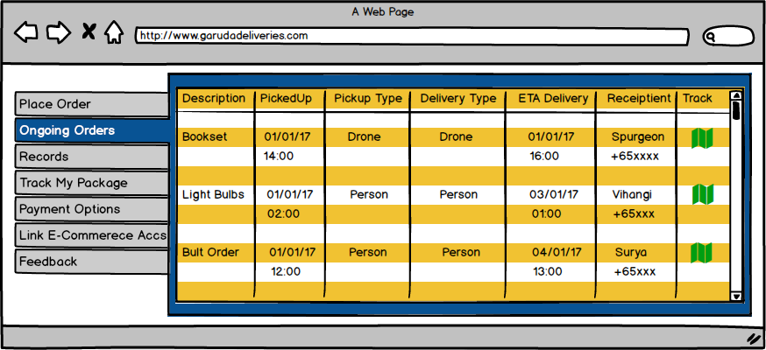

**Thoughts about the materials used for the prototype:**

***Sketching Stage:*** Initially during the sketching stage we used pencils, pens to draw the first iteration. Then we designed it balsamiq software for the digital versions.

***StoryBoard.com*:** It was one of the most efficient ways to make a digital version of the storyboard. Our team initially thought of using drawings and color sketches to narrate the story we intend to tell. However, the time constraints in SPRINT did not give us an option to choose that method.

***Balsamiq software***: Creating mockups and wireframes has never been more efficient than with the Balsamiq software. It’s easy to use interface helped our team make quick mockups in significantly lesser amount of time.

***Marvel app***: It is one of the best tools we can use for the lean UX process. Our team was able to quickly produce clickable prototypes, and revised them with no problems at all. This app also helped us to sync our files with Marvel through our Dropbox accounts. We have tried to use other kinds of softwares for the previous assignment but none of them had the efficiency of delivering a proper output in quick time as the marvel app

**Thoughts of other people on the design:**

While user testing, we had a chance to show our final design to our fellow classmates. They were extremely impressed with the design of the final product. Especially with the way we presented the whole features in the final design. Even little details like using optimal colored backgrounds to highlight the text was noticed by some students. The use of vehicle images for pickup types was appreciated as an easy interface. Providing a tracking ID and enabling it to be used to track the “package status” on the map gained user’s acknowledgement. The most appreciated feature was the “Drone Delivery”. Every student, who saw our design, was interested in knowing the actual workings of this delivery system. How would the package be picked up by the customer? How long will it take for the drones to reach the destination in comparison to normal transports? What if there are repairs? What are the costs involved in monitoring this technology? These are some of the questions that people posed when we showed them our design. The team felt happy that this subject was relevant to so many students, and felt the urge to work towards a similar project in future provided the means and resources to do it.

**Prototypes by other teams:**

I was fortunate enough to do multiple user testings for other teams. So I was able to understand their designs as well. Infact, I user tested a product based on the similar challenge my friends picked. However, they were making an app highlighting the problems the delivery men face while transporting goods. It was an interesting way of looking at the same issue from a different perspective. We were looking it through the eyes of a retailer and they were looking at it from the problems the delivery men face. The problems were similar but the solutions offered were slightly different in their application It was more about saving the costs involved by streamlining the whole transport system by bringing different systems under one functioning roof. It sounded like a compelling idea to me, which I would like to try out in my future endeavors.

**Personal reflection on the Prototype Experience:**

The “Prototype” experience has taught me the value of testing our product multiple times before we actually make our final version. This was evident in the changes we made based on the user insights. I believe it is an essential step to make a good product. This lean UX method of constantly going back to the user is probably most effective for new startups with budget and time constraints.

**Reflection of Teamwork:**

***Dynamics of the team:***

Our team comprised of the same members who worked during the previous assignment. But the setting for the teamwork was different this time during the SPRINT. During our previous collaboration as a group there was not a necessity to work in a boxed-time condition. Everything was done at our own pace. But SPRINT needed our work efficiency to multiply in order to reach our desired goals. Our roles had to be interchanged to provide faster progress on the project. There was a subtle shift in the whole mechanics of our group functioning but the overall dynamics of the team was relatively unaltered.

Our team thought it would be better for each individual member to play the same roles that engaged in the previous assignment. This will give us an initial foothold on the tasks at hand. As a team leader, I would like to give a brief summary of the roles I assigned for the individual group members.

Uday - Team leader, Designer, Documentation, user testing

Sudheer- Designer

Vihangi- Storyboard sketching, Interview taker

Spurgeon – Online research, Interview taker

Surya – Designer, Story board

***My Individual Contributions to the project:***

* Team leader, assigning roles to each members and checking on their progress regularly.
* Gave initial ideas about the basic website layout and interface
* Conducted research on topics which include drone technology for delivering goods.
* Designed the “Place an Order”, “Ongoing Orders” and “Track the package” pages in the first iteration
* Designed multiple pages during the second iteration using the Balsamiq software
* Wrote the script for the story board
* Conducted user testing for the first two iterations.
* Redesigned the “Ongoing orders” page in the third iteration.
* Documentation of the final report.

The defining part of our group functioning was the ease in which we fitted into our individual roles again during this round of the SPRINT. But the special conditions of the SPRINT forced us to interchange our roles based on the requirements. There were times when I had to leave my designing work midway to attend to another task of helping out a group member with the storyboard. Instead of wasting time some other member would pick up my work and start from where I left. It was like passing a baton from player to the next, a team sprint. This essentially helped us in accomplishing the tasks much faster. Our team was able to finish the final MVP on time and present it to the lecturer.

However, there were inconsistencies in our work that needs to be mentioned. This kind of collaborative attempts at work were necessary to finish the project on time, but it was not the best way of doing things. This is evident in the first iteration of our prototype design. Some pages were designed multiple times because of lack of proper communication between the team members. It was a wastage of previous time and defeats the very purpose of the lean UX process. Even some of the first designs were inconsistent because of two members doing the same task in parts. I believe the urgency of doing things faster got to us initially in the SPRINT process. Later on, we settled down and worked collaboratively towards our collective goal. I have learnt a lesson of not to repeat such mistakes in our future endeavors. Working within the framework of a system with a predetermined mindset can ease the initial nerves and help us perform better.

***Interesting things:***

The most interesting thing about working with this group was realizing new things about the group members over time. I have known these members for a long time now, I have worked with them multiple times yet there are so many hidden talents within each member that surface only at the appropriate time. At the initial stage of the project I usually rely on the team member “Sudheer” to come up with a unique idea for our website that will help us make a standing impression on the customers. His knowledge of mobile applications and websites always made me rely on this member for constant inputs. However, this time the ideas came from another group member “Surya” who was always a silent observer of events in the entire group. He revealed his inner passion relating to modern technologies and the novel ways in which they are applied to solve the day to day problems of consumers. Another instance was when I left my designing work for a while to finish the storyboard, my other group member “Spurgeon” picked it off where I left and started working on it. I was surprised at the ease he was using the Balsamiq software as he was not involved in the design process during the previous assignment as well. This kind of collaborative behavior helped our team in reaching our targets on time. By knowing their own talents and channeling it towards a collective goal, our members were able to maintain a spirit of camaraderie throughout the two days of the SPRINT.

***Most Fulfilling part:***

The most fulfilling part of the exercise for me was to finish the task on time. Initially I was unsure if this would happen, considering the difficulty of the challenge we were facing. However, a cohesive atmosphere created within the group helped us work towards our goal in a step by step manner. I believe, setting intermediate goals was the crucial part of this whole exercise. We were trying to accomplish individual tasks in a stipulated time frame and that eased the process in the end.

***Least Fulfilling part:***

The least fulfilling part for me was the initial delays we faced on the first day of the SPRINT. This was partly due to the work pressure that was accumulating in all of us overtime owing to the tight exam schedules. But the main problem was that some design choices we made initially led us on the wrong track. Initially we were unable to come to a decision on our target users. We thought of looking at the problem from the perspective of both the retailers as well as the consumers. This led us on a hard path of tracking the needs of both the users at the same time. It took us time to settle down and analyze the problem from a single perspective and address it accordingly. In the end we came to the conclusion that our target users will be the retailers and addressing their issues will mostly address the issues of the consumers as well. However, in the context of the SPRINT, this could have turned into a costly mistake as time was running out for us to deliver the end product. I would like to correct such mistakes in my future work.

***Values of Teamwork:***

Going through different phases of transition during our group work helped me understand the importance of team culture in our daily lives. Our group which was not functioning as efficiently in the beginning stages of the SPRINT was able to transform into a well-functioning unit by the end. This was possible because of the understanding we have as a team. We know our strengths and weaknesses and try to adjust according to the sensibilities of our fellow group members. This has been the most admirable quality that helped us work together as a complete unit. It gave an enriching feeling of satisfaction working within the framework of this group.

***Strengths in Teamwork:***

My experience during the SPRINT made me realize the importance of teamwork in accomplishing a particular task. If the team can allocate their tasks according to their individual talents and work to accomplish a common goal, it will be much more productive than working alone. Every person has a set of talents, and by identifying and assigning them accordingly we can accomplish much bigger things in life.

***Weakness in teamwork:***

There are some personal weaknesses I would like to address in my future group works. Sometimes I am unable to comprehend the delays by other team members in completing their tasks. For example, my team member(Spurgeon) was unable to conduct a user testing on time and I was worried because the time for the SPRINT session was running out. But later I realized that different people work at different speeds and we need to adjust and move on to work as a group. It is a weakness I need to address for my next group venture. I also need to ensure that members are given sufficient freedom within the framework of the group to yield optimal results. Intruding into the creativity of other people may not an effective way of working in a group. I have realized that sometimes people may make mistakes because of their lack of knowledge yet giving them a chance to correct it and work allows for a healthy functioning of a group.

***Personal reflection on Sprint:***

My experience in Sprint has taught me important lessons in life. There are many things I learned during this whole process. I have learned the importance of teamwork and companionship in working with a group. Understanding human emotions and adjusting to the needs of other people is paramount in working in a group. This, I believe, is one of the most valuable experiences in my life.

**Retrospective meeting:**

The team had a retrospective meeting on the 9th of February, two days after the Sprint. We had discussion on the whole process of designing the final product. We made a brief summary of all the work we did and shared some images and sketches. Overall, we felt satisfied with the final design of the prototype. The images and sketches produces during the meeting are listed below.



